­­

**جمهورية العراق**

**وزارة التعليم العالي والبحث العلمي**

**جامعة واسط**

**كلية التربية للعلوم الصرفة**

**قسم علوم حاسوب**

**Lost Thing Management System**

**نظام ادارة الاشياء المفقودة**

المشروع مقدم الى كلية التربية

للعلوم الصرفة / جامعة واسط / قسم الحاسوب

كجزء من متطلبات نيل شهادة البكالوريوس في علوم الحاسوب

**أشراف :**

**ا. م . د. اسم المشرف**

**من قبل:**

**محمود شمران عذيب**

**2021-2022 العام الدراسي**

Supervisor Certificate

I certify that the preparation of this project entitled " Lost Thing Management System " for Graduation project in Computer Science Department / College Education for Pure Sciences Wasit University, prepared by “اسم الطالب الاول” and “اسم الطالب الثاني”, partially fulfilling the requirements of a Bachelor's degree of Computer Science.

The name: Asst.Prof.Dr. اسم المشرف

Date:

Signature:

بسم الله الرحمن الرحيم

**))**هُوَ الَّذِي بَعَثَ فِي الْأُمِّيِّينَ رَسُولًا مِّنْهُمْ يَتْلُو عَلَيْهِمْ آيَاتِهِ وَيُزَكِّيهِمْ وَيُعَلِّمُهُمُ الْكِتَابَ وَالْحِكْمَةَ وَإِن كَانُوا مِن قَبْلُ لَفِي ضَلَالٍ مُّبِينٍ **((**

صدق الله العظيم

### **[سورة الجمعة - الآية 2](http://quran.ksu.edu.sa/tafseer/katheer/sura62-aya2.html)**

**الاهداء**

أيام مضت من عمرنا بدأناها بخطوة وها نحن اليوم نقطف ثمار مسيرة أعوام كان هدفنا فيها واضحا وكنا نسعى في كل يوم لتحقيقه والوصول له مهما كان صعبا وها نحن اليوم نقف أمامكم وها نحن وصلنا وبيدينا شعلة علم وسنحرص كل الحرص عليها حتى التنطفئ ونشكر هنا أول وأخير على من وفقنا وساعدنا على ذلك ثم نتقدم بالشكر إلى القلب الحنون من كانت بجانبنا بكل المراحل التي مضت من تلذذت بالمعاناه وكانت شمعه تحترق لتنير دربنا إلى أمهاتنا الحبيبات وإلى من علمنا أن نقف وكيف نبدأ ألف ميل بخطوة إلى يدنااليمنى إلى من علمنا الصعود وعيناه تراقبنا ....والدنا لمن أمسك بيدينا وعلمنا حرفا ..حرفا ..سنهدي له نجاحنا اليوم إلى من كانوا سندا لنا إلى من لهم الفضل بإرشادنا إلى طريق العلم والمعرفه إلى أساتذتنا األفاضلين كم نحن فخورون بكم أصدقائنا وأحبتنا ومن سهروا معنا في مسيرتنا العلميه إلى من مدوا أياديهم البيضاء في ظالم الليل وكانوا عونا لنا……

**شكر وتقدير**

نتقدم بلشكر والتقدير الئ النفوس التي نذرت نفسها رغم الصعاب في اعلاء صرح العلم واخص دكتورنا المشرف **ا.م.د. اسم المشرف** الذي اشرف علئ هذا المشروع ومنحنا من وقته الكثير فكان رايه السديد مما كان له الاثر في اخراج هذا المشروع بهذه الحله الئ حيز النور

وفائق شكرنا وامتنائنا لجميع اساتذتنا في قسم الحاسوب في كلية التربية للعلوم الصرفة

كما لايسعنا ان نتقدم بوافر الشكر والامتنان لجميع عائلتنا لما قدموه لنا في دعم ومساعده علمية معنوية

# الملخص

يمثل هذا النظام "نظام إدارة الأشياء المفقودة" المرحلة الحديثة في عالم التكنولوجيا للمساعدة في العثور على الأشياء المفقودة ، وهو نظام سهل وبسيط في الاستخدام والفهم ، يتميز بنوافذ رسومية جميلة تسهل على المستخدمين استخدام البرنامج والعثور عليه الاصناف المفقودة بدون استخدام مكاتب الاطارات الحديثة مع امكانية ادارة كاملة للمواد المفقودة من عمليات اضافة وتعديل وتحديث وحذف البيانات مع امكانية جرد الاصناف المفقودة وعمل احصائي كامل لجميع الاصناف المفقودة ومعرفة الرقم مع إمكانية عرض البيانات الكاملة مع إمكانية البحث عن العنصر المفقود بالاسم أو المكان أو المنطقة ، بالإضافة إلى إمكانية الترتيب حسب التاريخ ، أي معرفة العنصر المفقود ضمن نطاق زمني محدد ، أي الشهر ، الشهر ، السنة ، إلخ.

مع إمكانية تصدير البيانات إلى pdf بكل سهولة والقدرة على طباعة كافة التفاصيل دون تعب أو جهد.

## Abstract

This system represents " Lost Thing Management System" the modern stage in the world of technology to help find lost things, An easy and simple system to use and understand, characterized by beautiful graphical windows that make it easy for users to use the program and find lost items without using modern tire offices, with the possibility of full management of lost items from the processes of adding, modifying, updating and deleting data with the possibility of inventory and lost items and a total statistical work for all lost items and knowing the number with the possibility Full data display with the ability to search for the missing item by name, place or region, in addition to the possibility of arranging by date, i.e. knowing the missing item within a specific time range, i.e. month, month, year, etc.

With the possibility of exporting data to pdf with ease and the ability to print all the details without fatigue or effort.

# List of Contents

**سورة الجمعة - الآية 2** ii

الملخص v

Abstract vi

List of Contents vii

Chapter One 1

**Introduction** 1

1-1. Introduction -: 2

1-4. Research Problem -: 3

1-5. Aim Of Study-: 3

1-6. Research Objective-: 3

Chapter Two 4

**Applications and languages** 4

**used in the system** 4

**Propased System** 5

To build the lost Management system we need to: - 5

**2-1 Databases (SQL Server)** 5

**2-2. Visual Basic Language** 7

**2-2-1. Programming In Visual Basic:** 7

**2-2-2. Visual Studio Environment is:** 7

**2-2-3. Visual basic Program Structure :** 8

**2-2-4. Visual basic - Basic Syntax:** 9

**2-2-5. Variables:** 9

**2-2-6. Decision Making:** 10

**2.2-7. Loops:** 10

**Loop Type Description** 11

**2-2-8. Arrays** 11

**2-2-9. Functions and Sub** 12

**2-2-10. Classes & Objects** 12

**2-2-11. Windows Forms Application Basics** 13

Chapter Three 14

**System Implementation** 14

**and Model** 14

Chapter Four 18

**Result and Discussion** 18

Chapter Five 25

5-1. Conclusion 26

5-2. Recommendation 26

5-3. Future Work 26

The References 27

# **Chapter One**

## **Introduction**

## Introduction -:

An information system is a set of steps and procedures that are followed to operate a data processing system for the purpose of providing, generating, collecting, organizing, storing and retrieving information in an institution or any party in society about special activities or circumstances, and this is done using a set of supplies and resources, systems, and technical methods.

* 1. **Information System Components:**

1. Input: is the process of collecting data necessary to operate the system.
2. Operation: The processing that takes place on the inputs in order to obtain the outputs.
3. Outputs: are the outputs obtained after the completion of the operation process, and transferred to the output centers. Feedback: It is the process by which the system can evaluate its work.
4. Control: It is the process of following up and evaluating the feedback to ensure that it does not deviate from the proper path, and to make the required adjustments to the inputs and to the processing processes to reach the required results.
   1. **The main types of information systems**
5. production information system and production function; It is the process of converting a set of inputs into a set of outputs in the form of goods such as cars.
6. marketing information system; The marketing function means inventory management and physical distribution of finished products.
7. finance information system; It includes accounting functions.
8. Personnel Information System.
9. Accounting information system.

## Research Problem -:

A number of people suffer from the problems of losing something and finding it difficult to find, in addition to government departments facing many problems about managing lost data and instead of using paper records that expose the data to damage

## Aim Of Study-:

The system performs several functions of data management and storage operations, with the possibility of raising the database on a server, and all people can use it easily.

## Research Objective-:

Reducing the effort of employees responsible for managing lost items in government departments, institutions and other civil centers, in addition to helping people find their lost items.

The idea of the system aims at the beauty of the design, the lack of complexity and easy to use, meaning that anyone can use the site and this site can be converted into a mobile application that works on all Android and iPhone systems. Its easy to use.

# **Chapter Two**

## **Applications and languages**

## **used in the system**

## **Propased System**

## To build the lost Management system we need to: -

## **2-1 Databases (****SQL Server)**

It is a relational database management system based on SQL language , SQL Server is from Open source products. which is currently a division of Mircorsoft.

Q\ Why you using SQL not anther??

The most important features of database systems are speed and stability, which resulted in a system that stands out from its competitors without Sacrificing reliability or ease of use, and what distinguishes this rule :-

**Speed : 1-**

In database systems, velocity is defined as the time taken to execute a query and return the results For the query, and is very important to the success of any database system, and SQL Server has achieved high results in This field performs better than most of its competitors, including commercial systems such as Microsoft SQL Server and DB2 IBM, this performance is not just a coincidence, but the result of the innovative design of the system SQL Server uses a multitasking architecture, and optimizes for complex tasks such as indexing and contracting and queries cached in memory, all this improves performance without the need for any programming Customizable by the user, as well as the unique feature that allows choosing different save drives Each table separately.

**2-Security :**

Security is one of the important things when dealing with a multi-user database SQL Server developers have taken this field with great care to ensure that SQL Server is as secure as possible SQL Server has a complex access control and permissions system to prevent unauthorized users From access to the database, this system is implemented in the form of five layers of powers hierarchically, enabling SQL Server administrators to protect access to sensitive data Limit users to perform operations on certain databases or certain fields only, and allow SQL Server also has the ability to control the types of queries that a user can run on The database, table, or field level .

: **3-Support many applications**

SQL Server offers a programming interface for various programming languages to enable you to write database application In the language of your choice, it supports PHP, java, Tcl, C++, and others to give developers the freedom The ultimate in designing applications that are based on SQL Server

**4-Ease of use :**

The higher the complexity, the higher the total cost of owning a database, so the development team took SQL Server is responsible for making it easier to use, manage, and improve the performance of SQL Server. The interface The base of the SQL Server server is a simple inline interface, and there are two graphical clients for users Those who prefer graphical interfaces are Center Control SQL Server and SQL Server Administrator.

## **2-2. Visual Basic Language**

## **2-2-1. Programming In Visual Basic:**

Visual Basic is a third-generation event-driven programming language first released by Microsoft in 1991. It evolved from the earlier DOS version called BASIC. BASIC means Beginners' All-purpose Symbolic Instruction Code. Since then Microsoft has released many versions of Visual Basic, from Visual Basic 1.0 to the final version Visual Basic 6.0. Visual Basic is a user-friendly programming language designed for beginners, and it enables anyone to develop GUI window applications easily. In 2002, Microsoft released Visual Basic.NET (VB.NET) to replace Visual Basic 6. Thereafter, Microsoft declared VB6 a legacy programming language in 2008. Fortunately, Microsoft still provides some form of support for VB6. VB.NET is a fully object-oriented programming language implemented in the .NET Framework. It was created to cater for the development of the web as well as mobile applications. However, many developers still favor Visual Basic 6.0 over its successor Visual Basic.NET.

## **2-2-2. Visual Studio Environment is:**

The Visual Studio integrated development environment is a creative launching pad that you can use to edit, debug, and build code, and then publish an app. An integrated development environment (IDE) is a feature-rich program that can be used for many aspects of software development. Over and above the standard editor and debugger that most IDEs provide, Visual Studio includes compilers, code completion tools, graphical designers, and many more features to ease the software development process

## **2-2-3. Visual basic Program Structure :**

Before we study basic building blocks of the VB.Net programming language, let us look a bare minimum VB.Net program structure so that we can take it as a reference in upcoming chapters. VB.Net Hello World Example A VB.Net program basically consists of the following parts − Namespace declaration A class or module One or more procedures Variables The Main procedure Statements & Expressions Comments Let us look at a simple code that would print the words "Hello World" –

When the above code is compiled and executed, it produces the following result − Hello, World! Let us look various parts of the above program −

1. The first line of the program **Imports System** is used to include the System namespace in the program.
2. The next line has a **Module** declaration, the module *Module1*. VB.Net is completely object oriented, so every program must contain a module of a class that contains the data and procedures that your program uses.
3. Classes or Modules generally would contain more than one procedure. Procedures contain the executable code, or in other words, they define the behavior of the class. A procedure could be any of the following − o Function o Sub o Operator o Get o Set o AddHandler , RemoveHandler , RaiseEvent ,The next line( 'This program) will be ignored by the compiler and it has been put to add additional comments in the program.
4. The next line defines the Main procedure, which is the entry point for all VB.Net programs. The Main procedure states what the module or class will do when executed.
5. The last line **Console.ReadKey()** is for the VS.NET Users. This will prevent the screen from running and closing quickly when the program is launched from Visual Studio .NET.

## **2-2-4. Visual basic - Basic Syntax:**

VB.Net is an object-oriented programming language. In Object-Oriented Programming methodology, a program consists of various objects that interact with each other by means of actions. The actions that an object may take are called methods. Objects of the same kind are said to have the same type or, more often, are said to be in the same class. When we consider a VB.Net program, it can be defined as a collection of objects that communicate via invoking each other's methods. Let us now briefly look into what do class, object, methods and instance variables mean. Object − Objects have states and behaviors. Example: A dog has states - color, name, breed as well as behaviors - wagging, barking, eating, etc. An object is an instance of a class. Class − A class can be defined as a template/blueprint that describes the behaviors/states that objects of its type support. Methods − A method is basically a behavior. A class can contain many methods. It is in methods where the logics are written, data is manipulated and all the actions are executed. Instance Variables − Each object has its unique set of instance variables. An object's state is created by the values assigned to these instance variables.

## **2-2-5. Variables:**

A variable is nothing but a name given to a storage area that our programs can manipulate. Each variable in VB.Net has a specific type, which determines the size and layout of the variable's memory; the range of values that can be stored within that memory; and the set of operations that can be applied to the variable. We have already discussed various data types. The basic value types provided in VB.Net can be categorized as –

**Type Example**

**Integral** types **SByte, Byte, Short, UShort, Integer, UInteger, Long,**

**ULong** and **Char**

**Floating** point types Single and Double

**Decimal** types Decimal

**Boolean** types True or False values, as assigned

**Date types** Date

Example: - **Dim** x As Integer

## **2-2-6. Decision Making:**

Decision making structures require that the programmer specify one or more conditions to be evaluated or tested by the program, along with a statement or statements to be executed if the condition is determined to be true, and optionally, other statements to be executed if the condition is determined to be false. Following is the general form of a typical decision-making structure found in most of the programming languages –

## **2.2-7. Loops:**

There may be a situation when you need to execute a block of code several number of times. In general, statements are executed sequentially: The first statement in a function is executed first, followed by the second, and so on. Programming languages provide various control structures that allow for more complicated execution paths. A loop statement allows us to execute a statement or group of statements multiple times and following is the general form of a loop statement in most of the programming languages –

## **Loop Type Description**

Do Loop It repeats the enclosed block of statements while a Boolean condition is True or until the condition becomes True. It could be terminated at any time with the Exit Do Statement For...Next It repeats a group of statements a specified number of times and a loop index counts the number of loop iterations as the loop executes. For Each...Next It repeats a group of statements for each element in a collection. This loop is used for accessing and manipulating all elements in an array or a VB.Net collection.

* While... End While It executes a series of statements as long as a given
* condition is True.
* With... End With It is not exactly a looping construct. It executes a series
* of statements that repeatedly refer to a single object or
* structure.
* Nested loops You can use one or more loops inside any another
* While, For or Do loop.

## **2-2-8. Arrays**

An array stores a fixed-size sequential collection of elements of the same type. An array is used to store a collection of data, but it is often more useful to think of an array as a collection of variables of the same type. All arrays consist of contiguous memory locations. The lowest address corresponds to the first element and the highest address to the last element.

For example,

1. Dim intData(30) ' an array of 31 elements
2. Dim strData(20) As String ' an array of 21 strings
3. Dim twoDarray(10, 20) As Integer 'a two dimensional
4. array of integers
5. Dim ranges(10, 100) 'a two dimensional array

## **2-2-9. Functions and Sub**

A procedure is a group of statements that together perform a task when called. After the procedure is executed, the control returns to the statement calling the procedure. VB.Net has two types of procedures −

1- Functions

2- Sub procedures or Subs

Note : Functions return a value, where as Subs do not return a value

Function FindMax(ByVal num1 As Integer, ByVal num2 As

Integer) As Integer

' local variable declaration */

Dim result As Integer

If (num1 > num2) Then

result = num1

Else

result = num2

End If

Return result

End Function

Sub CalculatePay(ByRef hours As Double, ByRef wage As Decimal)

'local variable declaration

Dim pay As Double

pay = hours * wage

Console.WriteLine("Total Pay: {0:C}", pay)

End Sub

## **2-2-10. Classes & Objects**

When you define a class, you define a blueprint for a data type. This doesn't actually define any data, but it does define what the class name means, that is, what an object of the class will consist of and what operations can be performed on such an object. Objects are instances of a class. The methods and variables that constitute a class are called members of the class. A class definition starts with the keyword Class followed by the class name; and the class body, ended by the End Class statement. Following is the general form of a class definition –

Class name [ ( Of typelist ) ]

[ statements ]

End Class

## **2-2-11. Windows Forms Application Basics**

An important part of Visual Basic is the ability to create Windows Forms applications that run locally on users' computers. You can use Visual Studio to create the application and user interface using Windows Forms. A Windows Forms application is built on classes from the System.Windows.Forms namespace.

# **Chapter Three**

## **System Implementation**

## **and Model**

3.1 - Overview: -

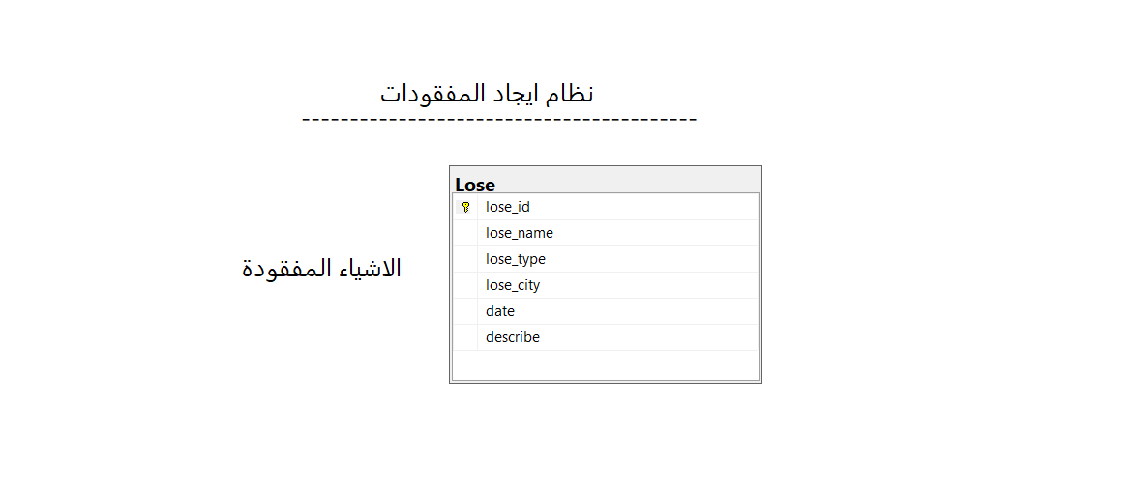This chapter contains the diagram of the project, which is a formal scheme that shows all the tables and data in the project, the relationships that connect the tables and the keys used, in addition to an explanation about them.

Figure 3- 1 - Table Lose

The Lose Table

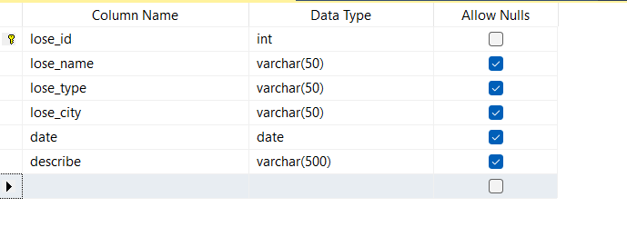

Figure.3- 2 - Table Users

The missing table is the table responsible for storing the missing item data, such as the missing item number, name, type, date of loss, description or note.

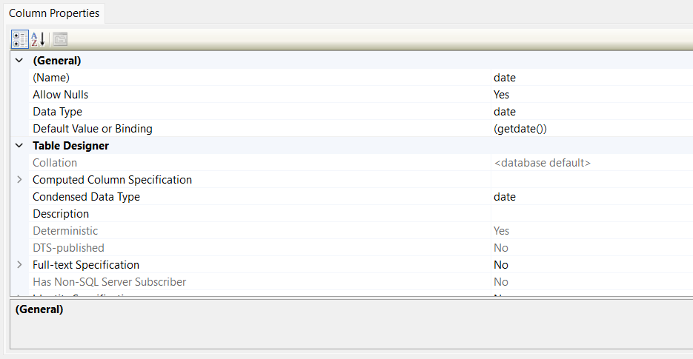

Figure 3-3 - General Table

Table data

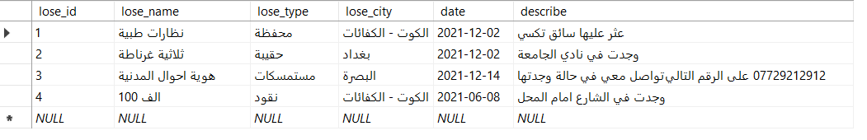

Figure 3- 4 - Table Data

**Codes Used To Create The Database**

The data can be displayed by selecting the missing table and then the fourth option to display the data or book a query to fetch data from the table.

/****** Object: Database [Lost Thing Managment System] Script Date: 3/10/2022 11:14:58 AM ******/

CREATE DATABASE [Lost Thing Managment System]

USE [Lost Thing Managment System]

GO

/****** Object: Table [dbo].[Lose] Script Date: 3/10/2022 11:15:51 AM ******/

SET ANSI_NULLS ON

GO

SET QUOTED_IDENTIFIER ON

GO

CREATE TABLE [dbo].[Lose](

[lose_id] [int] NOT NULL,

[lose_name] [varchar](50) NULL,

[lose_type] [varchar](50) NULL,

[lose_city] [varchar](50) NULL,

[date] [date] NULL,

[describe] [varchar](500) NULL,

CONSTRAINT [PK_Lose] PRIMARY KEY CLUSTERED

(

[lose_id] ASC

)WITH (PAD_INDEX = OFF, STATISTICS_NORECOMPUTE = OFF, IGNORE_DUP_KEY = OFF, ALLOW_ROW_LOCKS = ON, ALLOW_PAGE_LOCKS = ON, OPTIMIZE_FOR_SEQUENTIAL_KEY = OFF) ON [PRIMARY]

) ON [PRIMARY]

GO

ALTER TABLE [dbo].[Lose] ADD CONSTRAINT [DF_Lose_date] DEFAULT (getdate()) FOR [date]

GO

# **Chapter Four**

## **Result and Discussion**

**4-1. Splash Screen:**

welcome window: It is the first window that appears when the program is running. It contains a Progress Bar, which is a counter that increases automatically when the counter value becomes 100. The window closes and the next window opens, which is the login window.

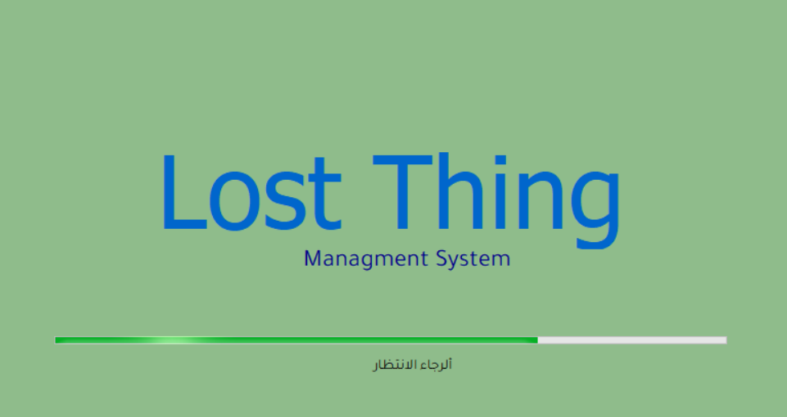

Figure 4-1 - Splash Screen

**4-2. Start Form**

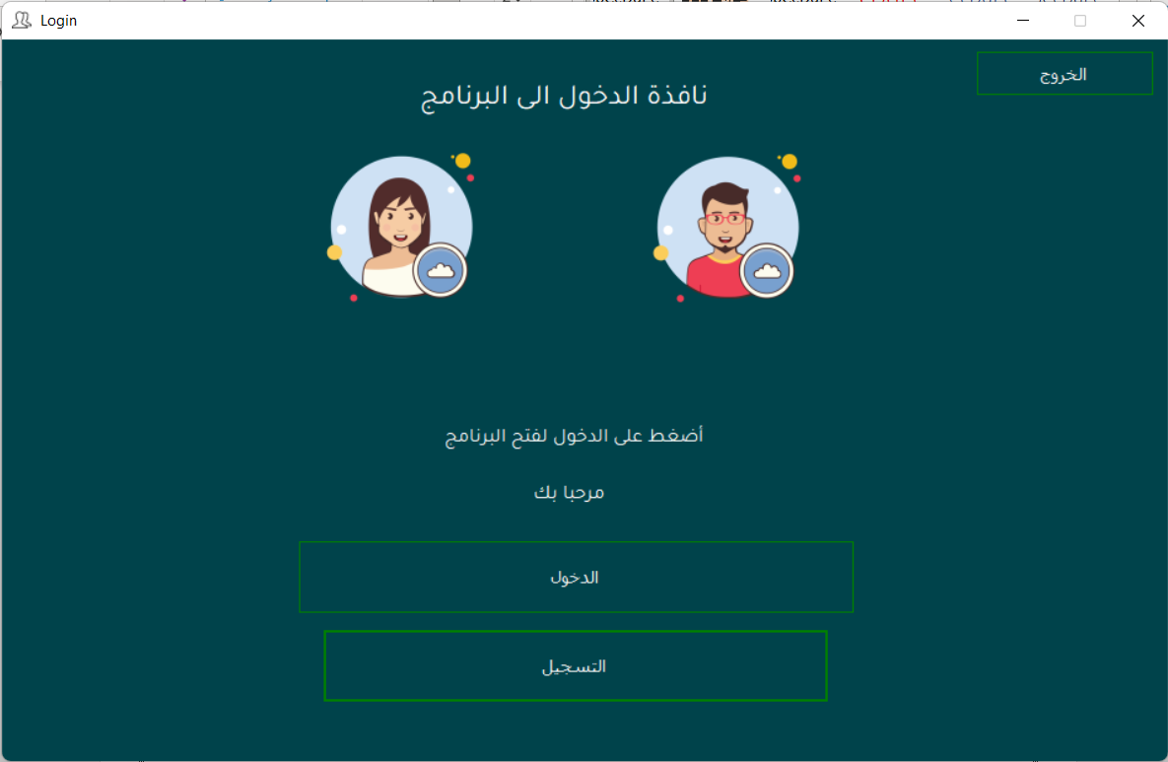

Figure 4-2 - Start Form

**4-3. Main Menu:**

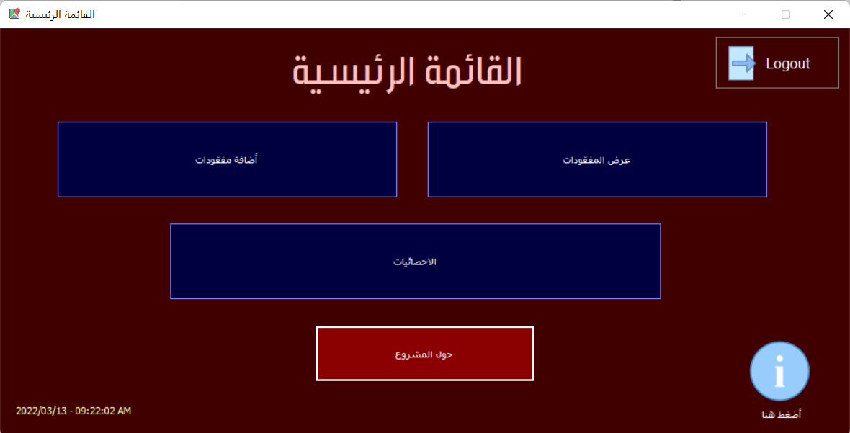 The main menu of the program and through it you can enter any section easily.

Figure 4-3 - Main Menu

Department of communication and contact with the program director via number or e-mail.

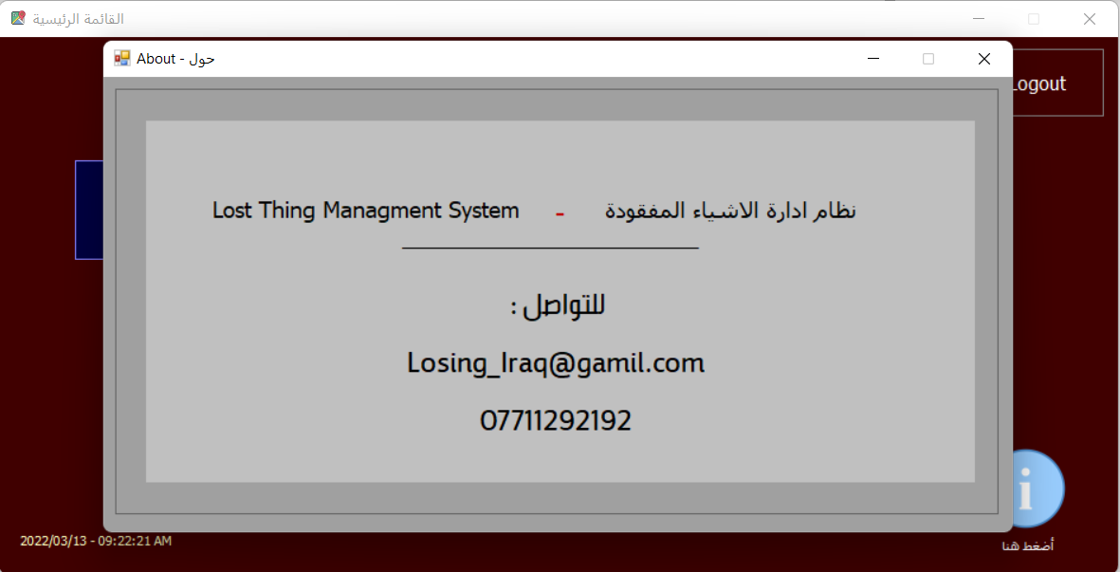**4-4. Contact with us:**

Figure 4-4 - Contact with us

4-5. Manage Data Lose:

You can easily manage lost and lost items through this window. You can add a new missing person, modify the missing data, or delete the missing one.

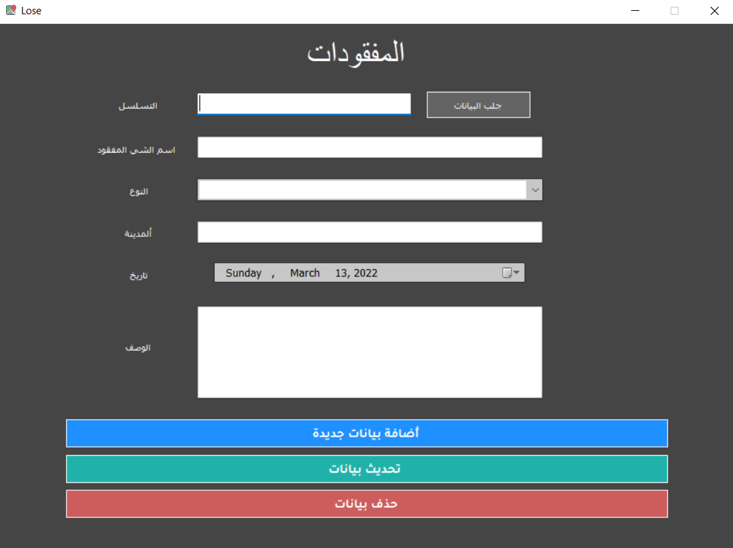

Figure 4- 5 - Manage Lose

Show Information:

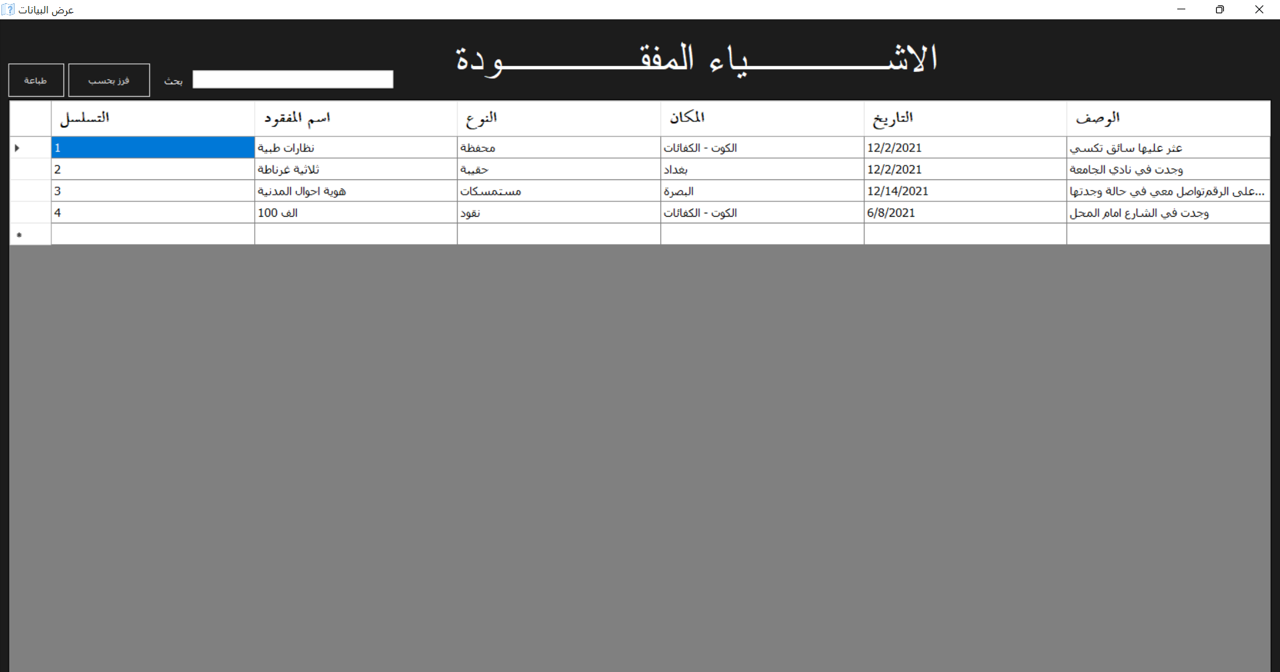

Figure4- 6 - Select All

**4-6. Print to PDF:**

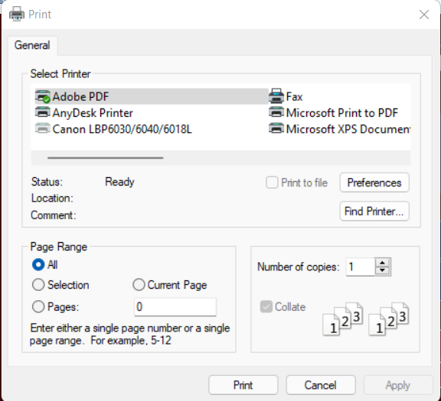

Figure4- 7 - Print to PDF

Quickly print the lost report by pressing the print button

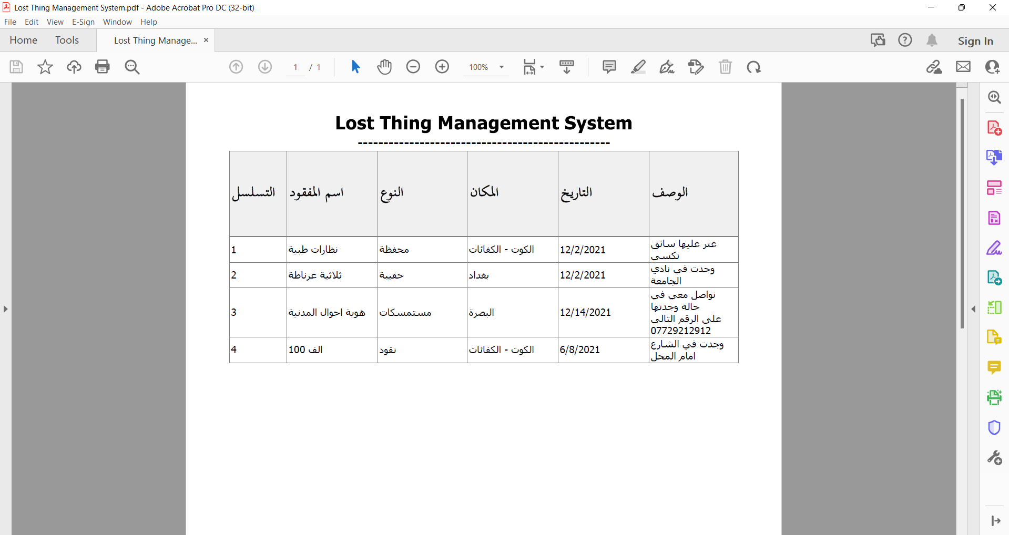

Figure4- 8 - Report

If you have a file browser from Adobe, you will find that the file opens automatically immediately after saving

**4-7. Show Information:**

The data display window. We notice that all the data appears inside the Gridview, and it can be easily searched and sorted by time, date, or type.

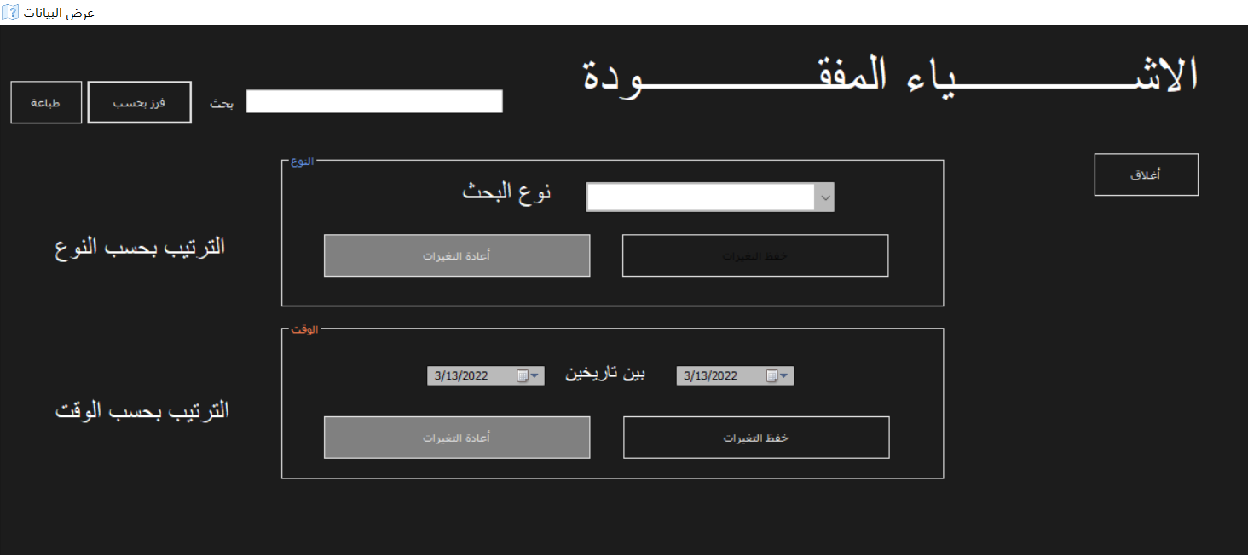

Figure4- 9 - Show Information

Inventory by date, time and type

**4-8. Total:**

We note in this list the appearance of the total data for each of the lost and users of each of them, and the final number.

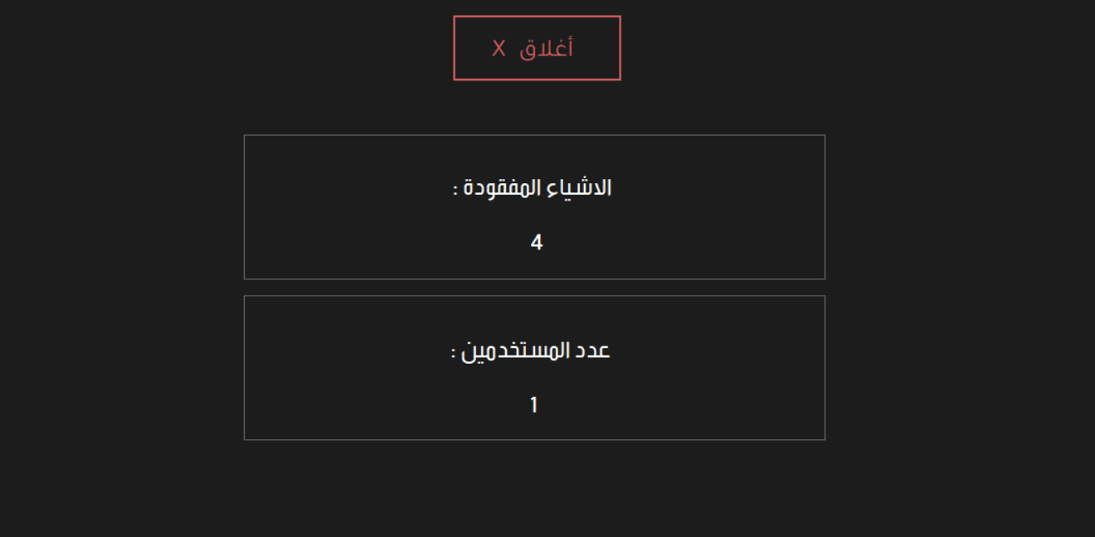

Figure 4-10 - Total

**4-9. About:**

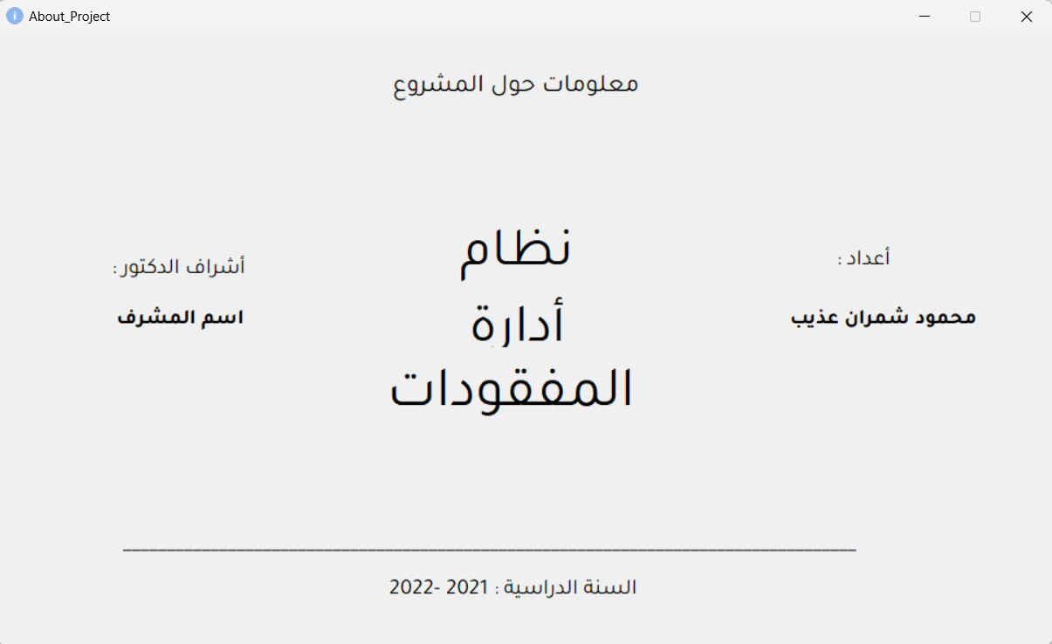

Figure 4-11 - About

The last window is the project information about the students working on the program and the name of the supervisor responsible for the students

# **Chapter Five**

**Conclusion & Future Work**

* 1. Conclusion

The project helps you manage the missing items and print their reports.

It also provides you with many reports about items and information.

It also provides you with the ability to display data in multiple sizes with the ability to search and arrange by time and inventory lost objects to make it easier for people to find them.

* 1. Recommendation

We recommend installing this project in all public and private Company and Malls, resorts and public entertainment places where lost items are often lost to be easily managed and to monitor all operations, Lost Things.

* 1. Future Work

Further system development could include programming the mobile version of application for Android and iOS operating systems.

It is possible to upload a database on hosting and follow up on the status of the lost from anywhere in the world with ease.

# **The References**

1. A. S. Sokolitsyn, M. V. Ivanov and N. A. Sokolitsyna, “Corporate Governance: Estimating Resource Providing Corporative Industrial Organization”, Proceedings of the 29th International Business Information Management Association Conference – Sustainable Economic Growth, Education Excellence, and Innovation Management through Vision 2020, IBIMA 2017; Vienna; Austria; pp. 191-200, 3-4 May 2017.
2. D.G. Rodionov, N.G. Fersman and O.A. Kushneva, “Russian Universities: Towards ambitious goals”, International Journal of Environmental and Science Education, Vol. 11, Issue 8, 16 June 2016, Article number ijese.2016.185, pp. 2207-2222.
3. A. S. Sokolitsyn, M. V. Ivanov and N. A. Sokolitsyna, “Financial Policy: Defining Short-Term Credit under Fixed and Circulating Capital for Providing Financial Sustainability of Industrial Enterprise Development”, Proceedings of the 29th International Business Information Management Association Conference – Sustainable Economic Growth, Education Excellence, and Innovation Management through Vision 2020, IBIMA 2017; Vienna; Austria; pp. 201-215, 3-4 May 2017.
4. <https://ar.wikihow.com/%D8%A5%D9%8A%D8%AC%D8%A7%D8%AF-%D8%A7%D9%84%D8%A3%D8%B4%D9%8A%D8%A7%D8%A1-%D8%A7%D9%84%D9%85%D9%81%D9%82%D9%88%D8%AF%D8%A9>
5. <https://en.wikipedia.org/wiki/Visual_Basic_.NET>
6. <https://www.tutorialspoint.com/d_programming/d_programming_variables.htm>
7. <https://sceweb.sce.uhcl.edu/helm/WEBPAGE-Fortran/myfiles/fortran-loops.html>
8. <https://sceweb.sce.uhcl.edu/helm/WEBPAGE-C/my_files/TableContents/Module-14/module14page.html>